10:45 AM Thursday November 11th Remembrance Day

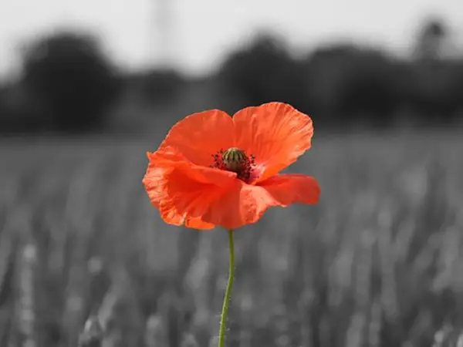
2 Minutes Silence at Market Square

