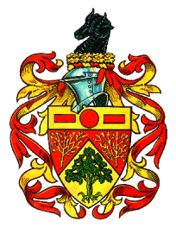

Civic Awards 2024

Southborough and High Brooms residents are invited to nominate someone who works in the voluntary sector and has provided ongoing service to our Community for a Civic Award.

For further information and a nomination form please see

www.southborough-tc.gov.uk

Or contact Southborough Town Council Offices, Southborough Civic Centre, 137, London Road, Southborough, Kent TN4 0NA

Closing date for all nominations is Friday 12 January 2024.

